**WEB & MOBILE PROGRAMMING**

**2022 / 2023 Semester 1**

**ASSIGNMENT**

Instructions and Guidelines:

1. Both Assignment 1 and Assignment 2 are individual assignments.
2. **Assignment 1** is to be handed in by **26 Jun 2022, 23:59.**

1. **Assignment 2** is to be handed in by **07 Aug 2022, 23:59.**
2. You are required to submit a soft copy of the project. The softcopy must contain source code and all required files i.e. images, javascript, css and html files. It can be submitted in the digital drop box for this module as a **zip** file. The name of the compressed file should be like “**pNNNNNNN.zip**” where NNNNNNN is your admission number.
3. The Assignment interview will be conducted during the session on the lesson after the submission date. No marks will be awarded if the work is copied or if you are absent from the presentation.
4. **5 marks will be deducted per working day late, up to a maximum deduction of 25 marks.**
5. **Assignment will NOT BE accepted after 12 Aug 2022 23:59, and 0 marks will be awarded for non-submission.**

# Assignment 2

# Progressive Web App

1. In your assignment, you are to create a mini-site for the Music / Song website you have been working on, as a Progressive Web App (PWA). PWAs are expected to be installable on mobile phones and respond to Push Notifications.
2. The site should have the three following screens:

* Listing
* Details
* Map

1. In the PWA/mini-site, you are required to retrieve live data by AJAX calls to populate the data into the two pages from the following URL:

<http://inec.sg/assignment/retrieve_records.php>

An example of the response JSON body

'{"last_update":"28-JUN-2018 09:54:51 GMT+0800","songs":[{"name":"Shape Of You","type":"Pop","artist":"Ed Sheeran","release":"yes","duration":3.53,"image":"https://inec.sg/assignment/images/song_0.jpg"},{"name":"Gangnan Style","type":"Pop","artist":"Psy","release":"yes","duration":3.39,"image":"https://inec.sg/assignment/images/song_1.jpg"},{"name":"Hotel California","type":"Rock","artist":"The Eagles","release":"yes","duration":6.3,"image":"https://inec.sg/assignment/images/song_2.jpg"}]}'

1. In the Listing screen, you are required to populate the results into a list in the following format. Each of the item is clickable to go to the Details screen.
2. In the Details screen, you are to display the item details in the following format. Users can tap on “WHERE TO FIND” button to go to the Map screen

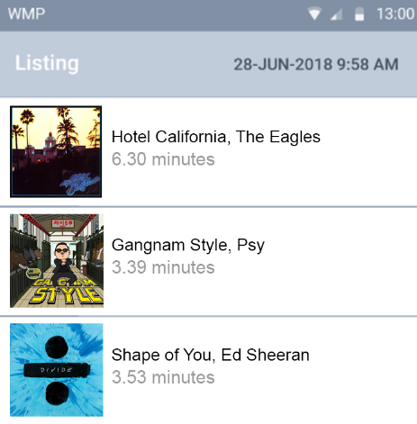 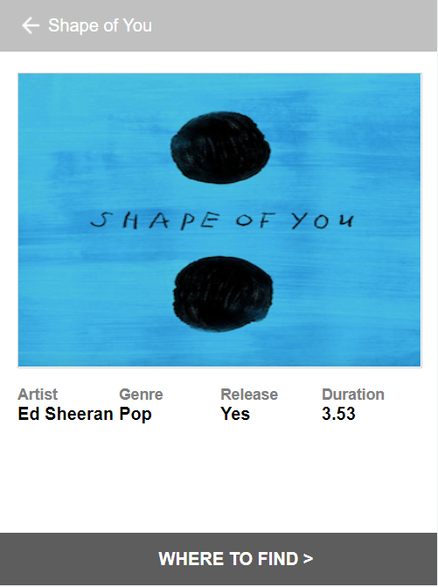

Songs Listing / Home Screen Song Details Screen

1. In the Map screen, user can add marker on the map view to store where the CD / music is sold. The location/s of the item is stored permanently using localStorage, so that they can be revisited and serve as a record for users.

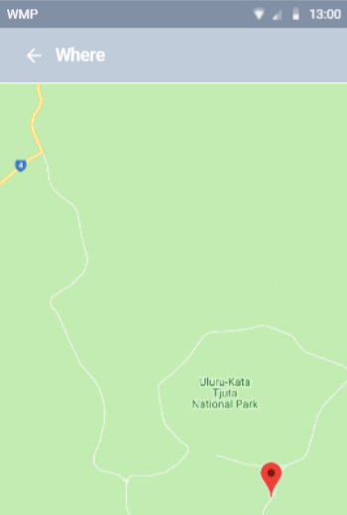

Where to Find Screen

Assessment

The project will be assessed based on the following criteria:

1. Implementation of a Google Map view with Interactivity

* Displaying of Map View
* Adding Marker

1. Use of Web Storage

* localStorage

1. Progressive Web App Properties

* Receive & Display Push Notification
* Installable as a Web App
* Defined with manifest configuration file

1. Updating UI view with dynamic AJAX calls

* UI changes instantly with AJAX calls to reflect updates from Web Service

1. Implementation of advance features in javacript/jquery

* Creativity and effectiveness of advanced features.

End